LAB EXPERIMENT RECORD
SET 17 – EMPLOYEE PERFORMANCE ANALYSIS

Department | AIDS
Course Code / Course Name | DSA0601 / Data Handling and Visualization
Experiment | Data Visualization using R
Name | M.Teja kumar
Register Number | 192424308
Date | 10 October 2026
Day | Saturday

Aim
To analyze employee performance using a line chart, department distribution bar chart, employee performance table, and an interactive dashboard in RStudio.

Dataset

Employee ID | Department | Years of Service | Performance Score
1 | Sales | 5 | 85
2 | HR | 3 | 92
3 | Marketing | 7 | 78
The supplied SET-17 dataset contains three employees from Sales, HR, and Marketing, with years of service and performance scores. The experiment record requirements are implemented using R/RStudio; the interactive dashboard is implemented here using Shiny for direct execution in RStudio.

PROGRAM 1: Line Chart – Employee Performance Trend
Aim: To create a line chart to visualize the performance trend of employees over time, using Years of Service as the x-axis and Performance Score as the y-axis.

R Program
# SET 17 - PROGRAM 1
# Employee Performance Trend

employee_id <- c(1, 2, 3)
department <- c("Sales", "HR", "Marketing") years_of_service <- c(5, 3, 7)
performance_score <- c(85, 92, 78)

employee_data <- data.frame( Employee_ID = employee_id, Department = department, Years_of_Service = years_of_service,
Performance_Score = performance_score
)
print(employee_data) plot(
employee_data$Years_of_Service,
employee_data$Performance_Score, type = "o",
pch = 16,
col = "blue",
main = "Employee Performance Trend", xlab = "Years of Service",
ylab = "Performance Score"
)

text(
employee_data$Years_of_Service, employee_data$Performance_Score, labels = employee_data$Employee_ID, pos = 3
)

legend( "topright",
legend = "Performance Score", col = "blue",
lty = 1,
pch = 16
)

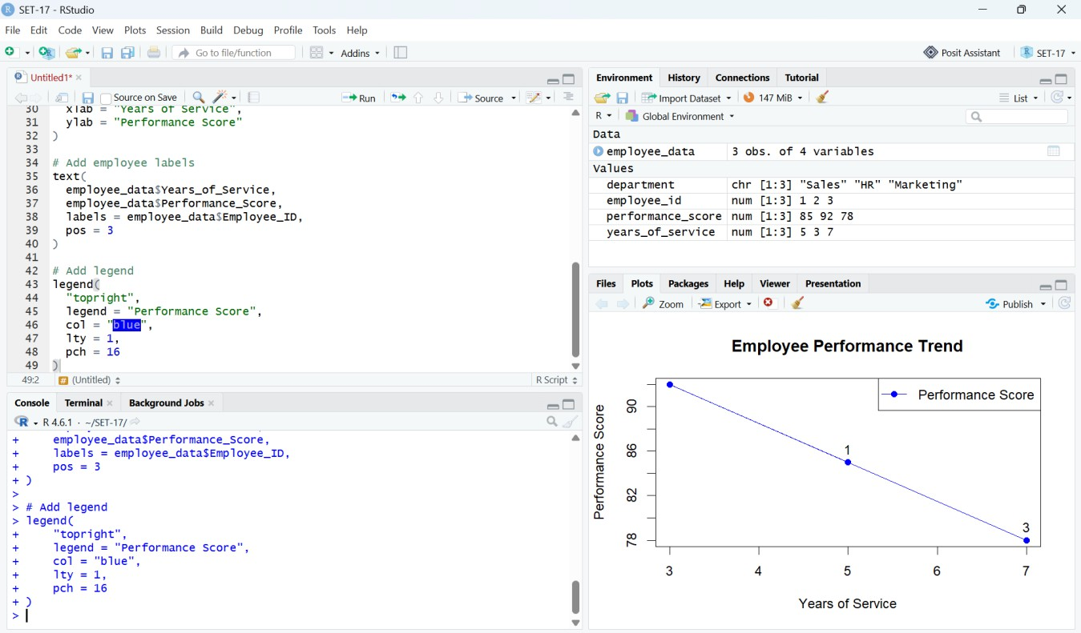

Observation
Output 1: Employee Performance Trend – RStudio Execution Screenshot

- Employee 2 has the highest performance score of 92 at 3 years of service.
- Employee 1 has a performance score of 85 at 5 years of service.
- Employee 3 has the lowest performance score of 78 at 7 years of service.
- The dataset contains only three employees, so the chart should be interpreted as a descriptive visualization rather than a general performance trend.

PROGRAM 2: Bar Chart – Distribution of Employees by Department
Aim: To generate a bar chart showing the distribution of employees across different departments and label the chart elements.

R Program
# SET 17 - PROGRAM 2
# Employee Department Distribution

employee_id <- c(1, 2, 3)
department <- c("Sales", "HR", "Marketing") years_of_service <- c(5, 3, 7)
performance_score <- c(85, 92, 78)

employee_data <- data.frame( Employee_ID = employee_id, Department = department, Years_of_Service = years_of_service,
Performance_Score = performance_score
)
department_count <- table(employee_data$Department) barplot(
department_count,
main = "Distribution of Employees by Department", xlab = "Department",
ylab = "Number of Employees", col = "lightblue",
border = "black"
)

text(
x = seq_along(department_count), y = department_count,
labels = department_count, pos = 3
)

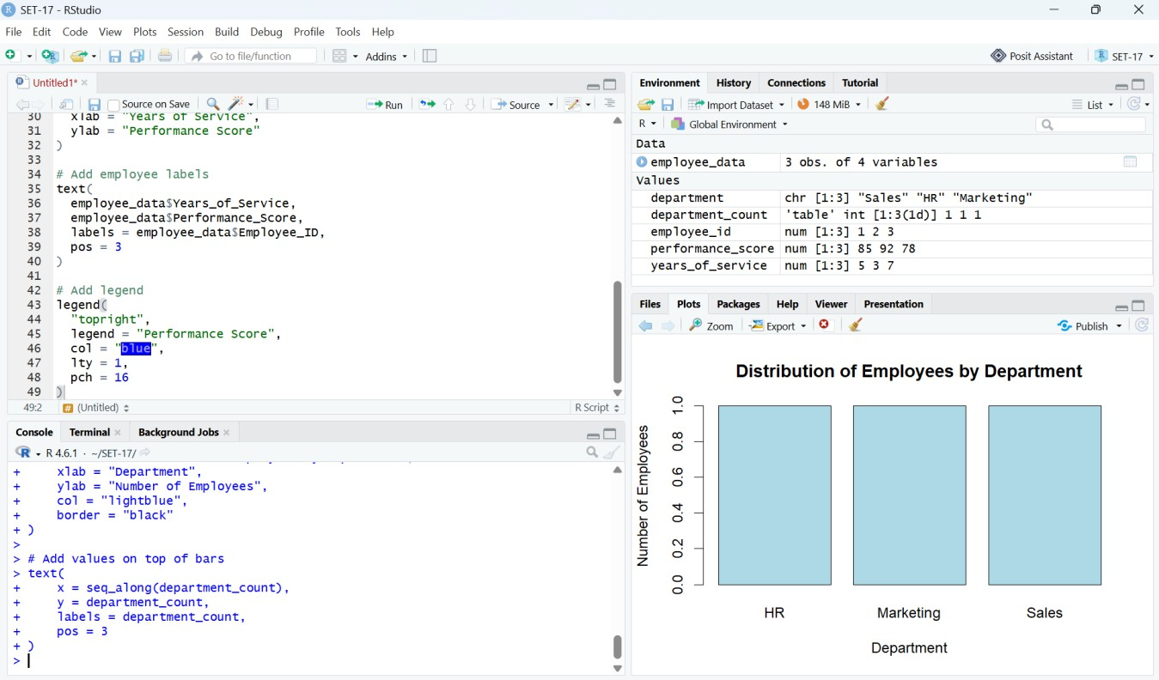

Observation
Output 2: Distribution of Employees by Department – RStudio Execution Screenshot

- HR, Marketing, and Sales each contain one employee in the supplied dataset.
- Therefore, every department has an equal employee count of 1.
- The bar chart provides a direct comparison of department representation.

PROGRAM 3: Employee Performance Data Table
Aim: To build a table displaying the performance data for each employee and label the table elements.

R Program
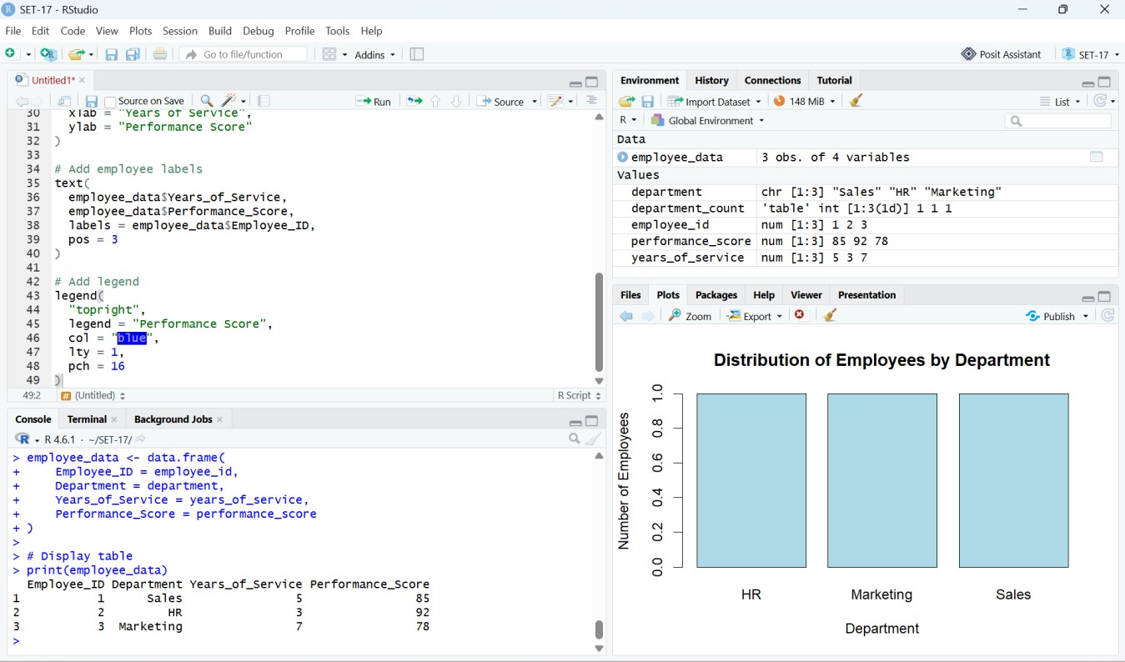
# SET 17 - PROGRAM 3
# Employee Performance Data Table

employee_id <- c(1, 2, 3)
department <- c("Sales", "HR", "Marketing") years_of_service <- c(5, 3, 7)
performance_score <- c(85, 92, 78)

employee_data <- data.frame( Employee_ID = employee_id, Department = department, Years_of_Service = years_of_service,
Performance_Score = performance_score
)

print(employee_data)

Observation
Output 3: Employee Performance Data – RStudio Console Screenshot

The table displays Employee ID, Department, Years of Service, and Performance Score for all three employees. It provides the exact values required for detailed comparison.

PROGRAM 4: Interactive Employee Performance Dashboard
Aim: To develop an interactive dashboard combining the employee performance line chart, department bar chart, and employee performance table. The dashboard is implemented in RStudio using Shiny so that the submitted screenshots correspond directly to the runnable practical.

R Program

# SET 17 - PROGRAM 4
# Interactive Employee Performance Dashboard

library(shiny) library(ggplot2)

employee_data <- data.frame( Employee_ID = c(1, 2, 3),
Department = c("Sales", "HR", "Marketing"), Years_of_Service = c(5, 3, 7),
Performance_Score = c(85, 92, 78)
)

ui <- fluidPage(
titlePanel("Employee Performance Dashboard"),

sidebarLayout( sidebarPanel(
selectInput( "selected_employee", "Select Employee:",
choices = c("All Employees", employee_data$Employee_ID), selected = "All Employees"
)
),

mainPanel( fluidRow(
column( 6,
h3("Employee Performance Trend"), plotOutput("performance_plot")
),
column( 6,
h3("Employees by Department"), plotOutput("department_plot")
)
),

hr(),

h3("Employee Performance Data"), tableOutput("employee_table")
)
)
)
server <- function(input, output) { filtered_data <- reactive({
if (input$selected_employee == "All Employees") {
employee_data
} else {

employee_data[ employee_data$Employee_ID ==
as.numeric(input$selected_employee),
]
}
})

output$performance_plot <- renderPlot({ data <- filtered_data()

ggplot( data,
aes(x = Years_of_Service, y = Performance_Score)
) +
geom_line(aes(group = 1), linewidth = 1) + geom_point(size = 4) +
geom_text(
aes(label = Performance_Score), vjust = -0.8
) +
labs(
title = "Employee Performance Trend", x = "Years of Service",
y = "Performance Score"
) +
theme_minimal()
})

output$department_plot <- renderPlot({ data <- filtered_data()
department_count <- table(data$Department)

barplot( department_count,
main = "Distribution of Employees by Department", xlab = "Department",
ylab = "Number of Employees", col = "lightblue",
border = "black"
)
})

output$employee_table <- renderTable({ filtered_data()
})
}

shinyApp(ui = ui, server = server)

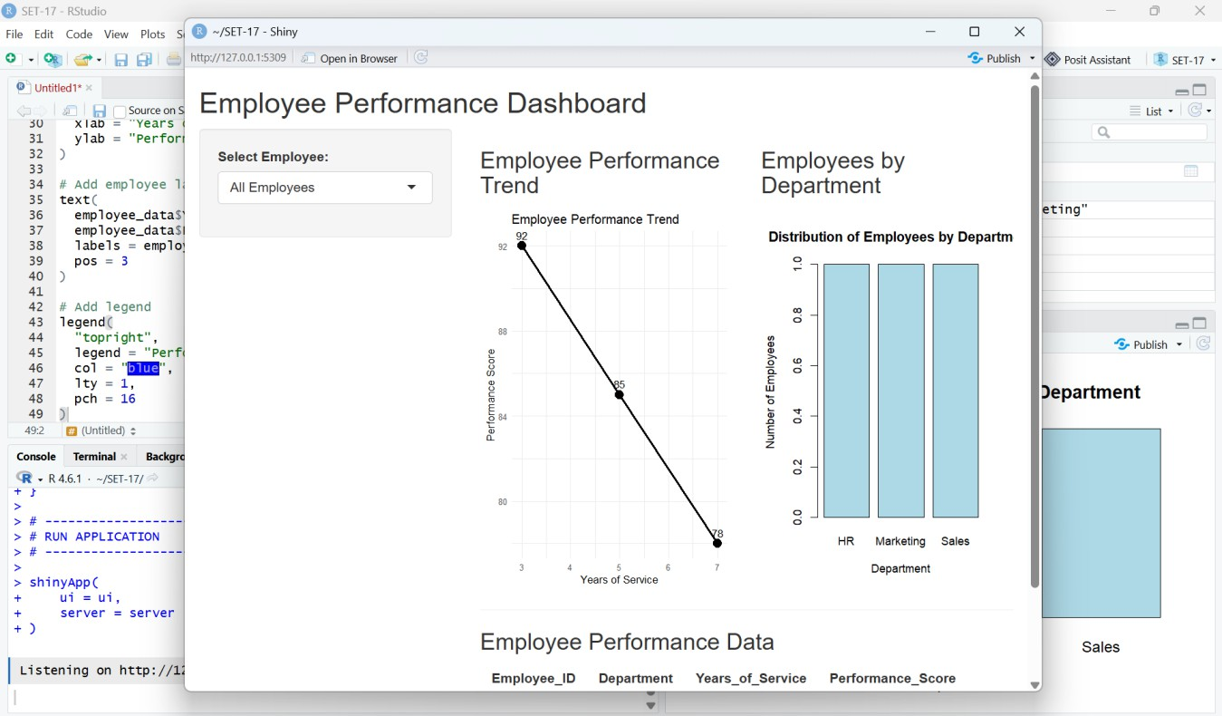

Output 4: Interactive Employee Performance Dashboard – RStudio/Shiny Execution Screenshot

PROGRAM 4: Dashboard Explanation Dashboard Components
- Employee selector: allows the user to choose All Employees or an individual employee.
- Employee Performance Trend: displays Years of Service against Performance Score.
- Employees by Department: displays the number of employees in each department.
- Employee Performance Data: displays the filtered employee records in tabular form.
- Reactive filtering: selecting an employee updates the displayed visualizations and table.

Observation
The dashboard integrates the three individual views into one interactive interface. When a specific employee is selected, the reactive data filter updates the performance chart, department chart, and table.

Result
The Employee Performance Analysis was successfully implemented in RStudio. The four required components—performance trend line chart, department distribution bar chart, employee performance table, and interactive dashboard—were created using the supplied SET-17 dataset.

Procedure
- Create vectors for Employee ID, Department, Years of Service, and Performance Score.
- Combine the vectors using data.frame() to create the employee performance dataset.
- Use plot() to create the performance trend line chart and label the axes.
- Use table() and barplot() to visualize department distribution.
- Use print() to display the employee performance table.
- Load shiny and ggplot2 for the interactive dashboard.
- Create the dashboard interface using fluidPage(), sidebarLayout(), selectInput(), plotOutput(), and tableOutput().
- Use reactive() to filter the dashboard when an employee is selected.
- Run the Shiny application and verify all three dashboard views.

Overall Insights
- Employee 2 (HR) has the highest performance score: 92.
- Employee 3 (Marketing) has the lowest performance score: 78.
- Employee 1 (Sales) has a performance score of 85.
- Each department has one employee in this dataset.
- The three observations are sufficient for visualization but too small to establish a general relationship between years of service and performance.

Result
The employee performance data was successfully analyzed using RStudio. The line chart, department bar chart, performance table, and interactive Shiny dashboard were developed and executed successfully.

SET-17 – Quick Viva Points

Question | Answer
What is the purpose of the line chart? | It visualizes performance score against years of service for the  employees.
What is the highest performance score? | 92, belonging to Employee 2 from HR.
Which department has the highest number of employees? | None; all three departments have one employee each.
What does table() do in Program 2? | It counts the number of observations in each department.
What does data.frame() do? | It combines related vectors into a tabular data structure.
Why is the dataset not enough to claim a strong trend? | It contains only three employee observations.
What is Shiny used for? | It is used to build interactive web applications and dashboards in  R.
What does reactive() do in the dashboard? | It recalculates filtered data when the selected employee changes.
What is plotOutput()? | It creates a placeholder for a plot generated by the server.
What is tableOutput()? | It creates a placeholder for a table generated by the server.

END OF SET 17 • EMPLOYEE PERFORMANCE ANALYSIS

